**Volunteer Match Program**

**Project Management Plan**

**CEN3031, Fall, 2017**

**Modification history:**

|  |  |  |  |
| --- | --- | --- | --- |
| Version | Date | Who | Comment |
| V0.1 | 10/8/2017 | Christopher Dreiser, Daniel Scamardella | Document ***mostly*** created. Names, emails, a few rough ideas put down. |
| V0.2 | 10/9/2017 | Brandon Walters | Established the Project Overview and Quality Assurance sections. |
| V1.0 | 10/10/2017 | Christopher Dreiser, Daniel Scamardella, Brandon Walters, Brett Dube | Finalized the details of this document. |

**Team Name:** The Gruntled

**Team Members:**

· Brandon Walters [btwalters8591@eagle.fgcu.edu](mailto:btwalters8591@eagle.fgcu.edu)

· Brett Dube [bwdube8586@eagle.fgcu.edu](mailto:bwdube8586@eagle.fgcu.edu)

· Daniel Scamardella [dcscamardella6157@eagle.fgcu.edu](mailto:dcscamardella6157@eagle.fgcu.edu)

· Rachel Snyder [resnyder2333@eagle.fgcu.edu](mailto:resnyder2333@eagle.fgcu.edu)

· Christopher Dreiser [cjdreiser1110@eagle.fgcu.edu](mailto:cjdreiser1110@eagle.fgcu.edu)

**Contents of this Document**

Project Overview

Applicable Standards

Project Team Organization

Timeline

Software Life Cycle Process

Tools and Computing Environment

Configuration Management

Quality Assurance

**Project Overview**

Our project is about creating a piece of software that allows Volunteers and Organizations to come together and give back to the community. The software we are designing will enable individuals as well as Volunteer Organizations to create/join volunteer opportunities in the area and start giving back. Individuals with also have the ability to create a joinable Volunteer Opportunity to allow for small scale opportunities such as school events. Additionally, volunteers will have personal pages showing their past and future volunteer events. This will allow Organizations to search for and invite volunteers to a nearby event based on interests in past and future events. Overall the vision for our project is to allow easy communication between individuals that want to give back and Organizations that make it possible.

**Applicable Standards**

* Coding standard will be the Java Sun standard as described here:<http://www.oracle.com/technetwork/java/codeconvtoc-136057.html>

**Project Team Organization**

The Gruntled Team consists of Brandon Walters, Brett Dube, Daniel Scamardella, Rachel Snyder, and Chris Dreiser. Each artifact will have a manager. Keeping and sharing the Meeting Minutes, Updating the SRS and the Project Management Plan will be handled by Daniel Scamardella. Rachel Snyder will be taking lead on the project's GUI development. Brett Dube will be responsible for the completion of Prototype and Presentation 1. Christopher Dreiser will take the lead on Testing and the Source, Executable, and Build Instructions. Brandon Walters will be the Manager of Design and the website. The Team will hold meetings once a week from 6:30 to 8:00 on Sundays, as well as a group text and canvas mail for any communications during the week.

**Timeline**

|  |  |  |
| --- | --- | --- |
| ***Artifact*** | ***Due Dates*** | ***Team member(s) responsible*** |
| Meeting Minutes | Within two days after each meeting. | Daniel Scamardella |
| Project Plan (document) | 10/10/2017 | Daniel Scamardella |
| SRS (document) | 10/10/2017 | Daniel Scamardella |
| Prototype | 10/29/2017 | Brett Dube |
| Design | 10/15/2017 | Brandon Walters |
| Test Results | 12/17/2017 | Christopher Dreiser |
| User's Manual (document) | 12/03/2017 | Rachel Snyder |
| Source, Executable, Build Instructions | 12/03/2017 | Christopher Dreiser |
| Presentation 1 | 10/29/2017 | Brett Dube |
| Presentation 2 | 12/17/2017 | Rachel Snyder |

**Software Life Cycle Process**

We will use the Rapid Prototyping model, because we like its iterative nature. The model also allows us to get a good feel for the project without wasting too much time planning in case something changes.

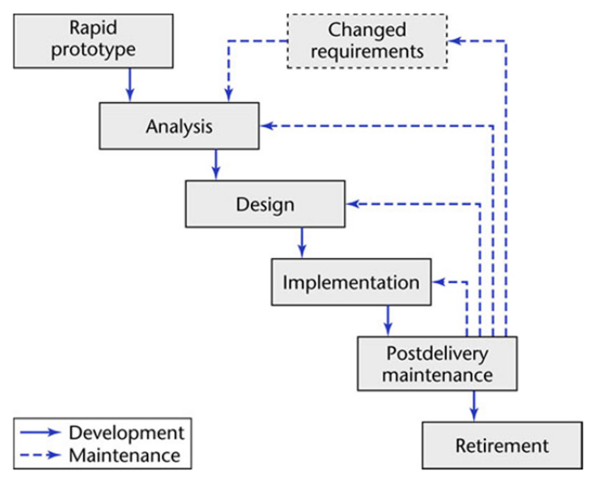

**Tools and Computing Environment**

We will use the Windows family of operating systems.

We will use the java language.

We haven’t decided what compilers to use or what libraries to use; aside from the standard Java one.

**Configuration Management**

We will be using GitHub to track changes made by each member. Any changes made will have to have a pull request approved by the artifact’s manager.

**Quality Assurance**

Our quality assurance activities will take place at our weekly Sunday meetings. This will allow the team to collaborate when assuring quality of each function implemented into our software. The team as a whole will be responsible for collaborating and submitting a report of quality assurance for each function implemented into our prototype.

Template created by G. Walton (GWalton@mail.ucf.edu) on Aug 30, 1999 and last updated Aug 15, 2000, modified by A. Koufakou Aug. 2014

This page last modified by Daniel Scamardella ( [dcscamardella6157@eagle.fgcu.edu](mailto:dcscamardella6157@eagle.fgcu.edu) ) on 10/10/2017